

Alternative Provision Inclusive Behaviour Plan

At Oasis our Ethos values are
- Inclusion – a passion to include everyone
- Equality – a desire to treat everyone equally, respecting differences
- Relationship – a commitment to healthy and open relationships
- Hope – a deep sense of hope that things can change and be transformed
- Perseverance– A sense of perseverance to keep going for the long haul

We live out our ethos through our Oasis nine habits, striving to develop character that is:
- Forgiving
- Self-controlled
- Compassionate
- Considerate
- Patient
- Humble
- Honest
- Hopeful
- Joyful

These ethos values and 9 Habits are the foundation of our activities, our intention and approach. This shared language empowers us to build a strong relational culture with inclusion and trust at its heart. Together, we work towards the Oasis vision for community, a place where everyone is included, making a contribution, and reaching their God-given potential.

This plan outlines how we set the culture and expectations for staff and students, how we encourage and celebrate and how we support and respond when needed.

Positive framing and celebrating success
The recognition of effort, achievement and accomplishment of goals is integral to our relational approach. We recognise that individual effort and achievements will look different for each child.
To develop genuine motivation from children we use the model of self determination theory and strive to embed the 3 key conditions for intrinsic motivation as often as possible. These are:
- Autonomy: having a sense of choice and control over what you do
- Mastery or competence: feeling that you have the skills to achieve success
- Purpose or relatedness: finding meaning and connection in what you are doing

Reward | Rationale
1:1 precise praise | Wherever possible we prioritise giving children specific and meaningful praise 1:1 so we can reflect together on how they accomplished the achievement and the pride we all feel about the effort they put in.
Whole class movie afternoon | We earn collective table points when we demonstrate fantastic behaviour for learning during independent and collaborative work time. These are recorded on a chart in our classrooms and every half term, if we have met the agreed threshold of 50 points per table, we agree on a movie to enjoy all together.

How we regulate and respond
We recognise that behaviour is the external symptom of a range of underlying factors, and that becoming dysregulated is an involuntary event and requires calming of the brainstem before rational decision making or discussion of cause or consequence can happen.
For this reason, we intentionally create an emotionally-aware environment, with physical space for calming, regulation and reflection. During sessions there is a separate quiet room available with soft furnishing where a student can take when feeling heightened or triggered.

We will work with the home school to support strategies used for each student, e.g. Zones of regulation, to support their capacity to manage the session in a regulated way. There are tools available for bottom-up regulation (such as breathing, grounding, sensory toys, lego, and drinking water) and top-down regulation (journalling, opportunity to vocalise feeling, naming and reframing, mindfulness tools).

Bottom-up regulation strategies:
Drinking cold water | Body percussion | Using square breathing or other breathing techniques | Throwing a ball/sock, paper into the air | Sensory toys
Listening to music | Humming | Watching a sand timer or bubble tube | Stroking a soft toy | Using playdoh or therapy putty
Top-down regulation strategies:
Mindfulness practices | Journalling | Gratitude practices | Recalling facts about a known topic | Using Zones of Regulation to name emotions
Imagining a favourite safe place | Writing a letter to share your side of the story | Drawing a picture or writing a poem about how you feel | Discussing how 9 Habits strengths link to positive choices | Completing a simple puzzle or game

Responsive Co-regulation
For some children, emotional dysregulation can lead to extreme and unsafe behaviours. At Oasis we recognise that early experiences of trauma and other additional needs can cause neurological developments that lead some children to respond differently to changes in their environment.
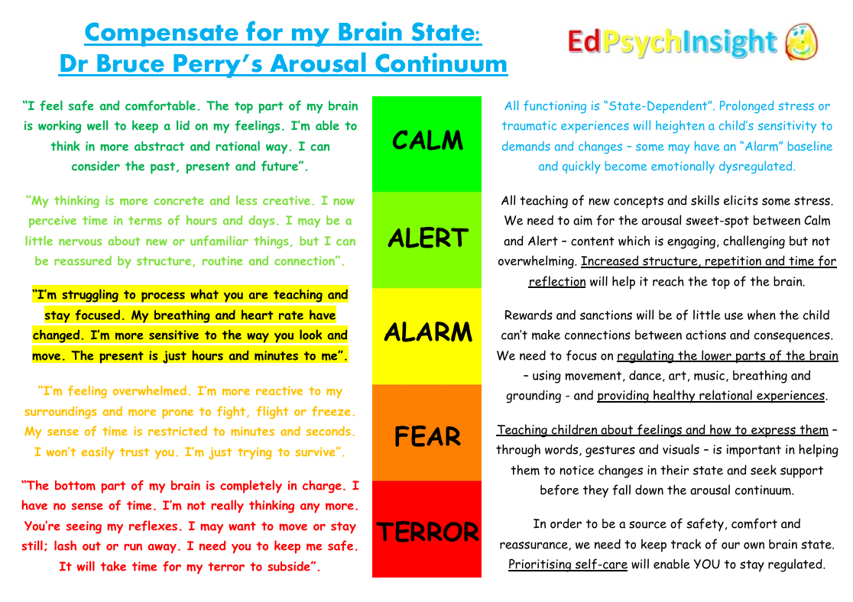
We use the behaviour cycle (1) and conflict curve (2) and Dr Bruce Perry’s arousal continuum (3) to help us understand and map the stages these children may go through in moments of dysregulation.

We map these stages through our Co-Regulation Planning tool. By matching the individual child’s behaviours to each stage of dysregulation that occurs, we are able to proactively plan to input the appropriate regulatory supports in before the child reaches peak dysregulation.
Internal state | Calm | Alert | Alarm | Fear | Terror
Brain system | Cortex | Cortex / Limbic | Limbic | Midbrain | Brainstem
Cognition | Rational & reflective, abstract reasoning, executive function, empathy | Concrete thinking, simple reasoning, emotions, relationships | Emotional, limited reasoning, triggered by echo of past experiences | Reactive, responding to survival impulses | Reflexive, controlled by survival impulses
Time awareness | Extended future | Day/hours | Hours / minutes | Minutes / seconds | Loss of sense of time
Internal development stage | Adult / Adolescent | Adolescent | Child | Toddler | Infant
Core question | What can I learn? | Do I belong? | Does anyone care? | Am I safe? | Can I survive?
Adaptive response continuum | At rest | Flock | Freeze | Flight | Fight
Hyperarousal behaviours | Calm and engaged | Vigilance | Resistance | Defiance | Aggression
Hypoarousal behaviours | Calm and engaged | Avoidance | Compliance (robotic) | Dissociation (shutdown, numb, non-responsive) | Fainting
De-escalating responses | PACEful adult presence, engaged learning, calm environment | Playfulness, structure, routine and connection, eye contact, calm voice, top-down regulation | Acceptance & empathy, matched affect, invited physical touch, top-down and bottom-up regulation | Acceptance & empathy, curiosity, time to calm, bottom-up regulation | Safety cues, acceptance & empathy, safe space, time to calm, appropriate physical restraint
Escalating responses | Noise, disruption to structure and routine, confrontation | Complex directives, anger, ultimatums, frustration, anxiety | Raised voice, defensiveness and judgement, chaos and noise in environment | Increased or continued frustration, yelling, sense of fear, isolation | Inappropriate physical restraint, screaming, shaming

Context
We recognise the importance of building a proportionate understanding of the child’s context, needs and strengths and planning helpful responses in collaboration with the home school. We use strategies recommended by those that know the child well and follow any support plans in place that are transferable to the Alternative Provision setting. A risk assessment will be completed by the home school prior to placement to that our staff are able to respond positively to keep the child, others and the environment safe.

Our staff are not trained in restrictive interventions and will not be in a position to accept referrals for pupils who regularly need de-escalation and high level behaviour plans.

Maintaining appropriate behaviour and boundaries
We seek to ensure that every interaction between adults and children in the setting is relational and restorative in nature. We use positive prompts to the whole group, assuming the best and reminding of the positive not the negative. Alongside positive reward and praise and relational leadership, we will address behaviours that challenge. We will ask for and model the behaviour we want to see. We will use affect statement, such as ‘I feel’ to connect relationally with students, name the behaviour and redirect back to tasks. We will then use a separate one to one conversation with a student to think more about positive behaviour change if needed. These are open, curious and positive discussions, without personalising or lecturing. Logical consequences will be in place as agreed with the home school and student at the start of the placement.

Reviews
All students will have an agreement and signed Learner Code of Conduct at the outset of the placement. All behaviour incidents or low level concerns will be shared with the home school and parents as appropriate and risk assessments, aims and outcomes will be reviewed 6 weekly or sooner.

Further information can be found in the Staff Code of Conduct, Learner Code of Conduct and the Safeguarding Policy.

References:
  - Hannah Smith. Beyond Autism. Understanding the Behaviour cycle (2023). Understanding the Behaviour Cycle - BeyondAutism
Behaviour_Cycle_template.pdf
  - Andrea Reid-Kelly and Deb Steggall www.togethercentre.co.uk
Understanding challenging behaviour Chapter 1 - Together
  - Dr Chris Moore. EP Insight.com 2020 Compensate for my Brain State: The Arousal Continuum

